CSA0603-Design-and-analysis-of-algorithms
1.Write a program that takes an input list of n numbers and creates a new list containing only the unique elements from the original list. What is the space complexity of the algorithm?
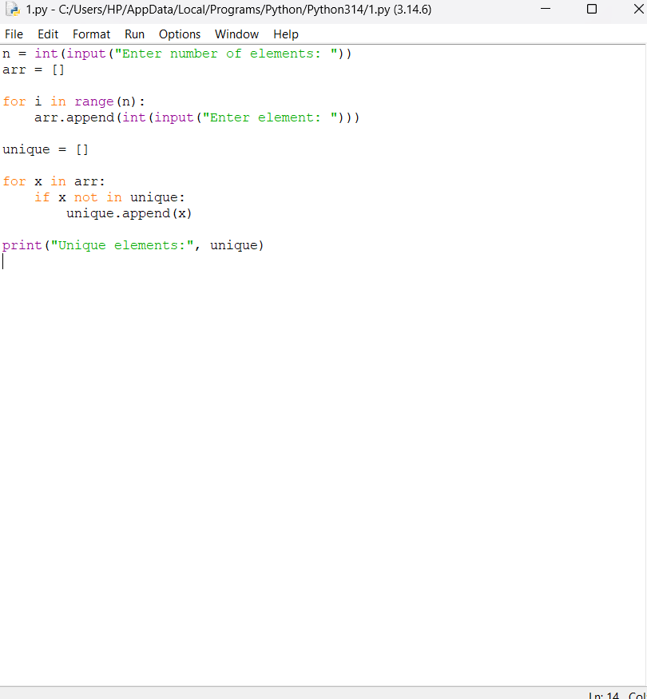

2. Sort an array of integers using the bubble sort technique. Analyze its time complexity using Big-O notation. Write the code
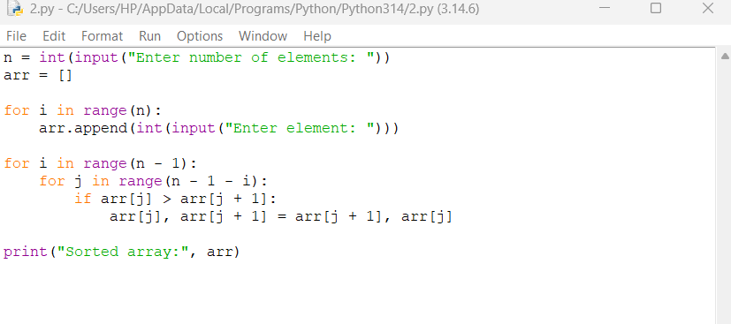

3. Checks if a given number x exists in a sorted array arr using binary search. Analyze its time complexity using Big-O notation.
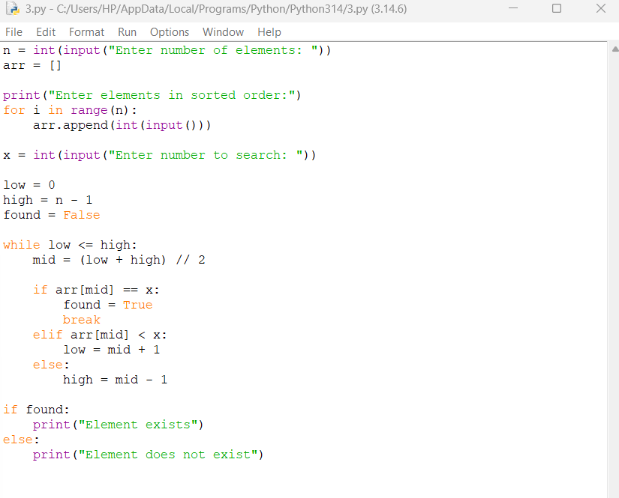

4. Given an array of integers nums, sort the array in ascending order and return it. You must solve the problem without using any built-in functions in O(nlog(n)) time complexity and with the smallest space complexity possible.
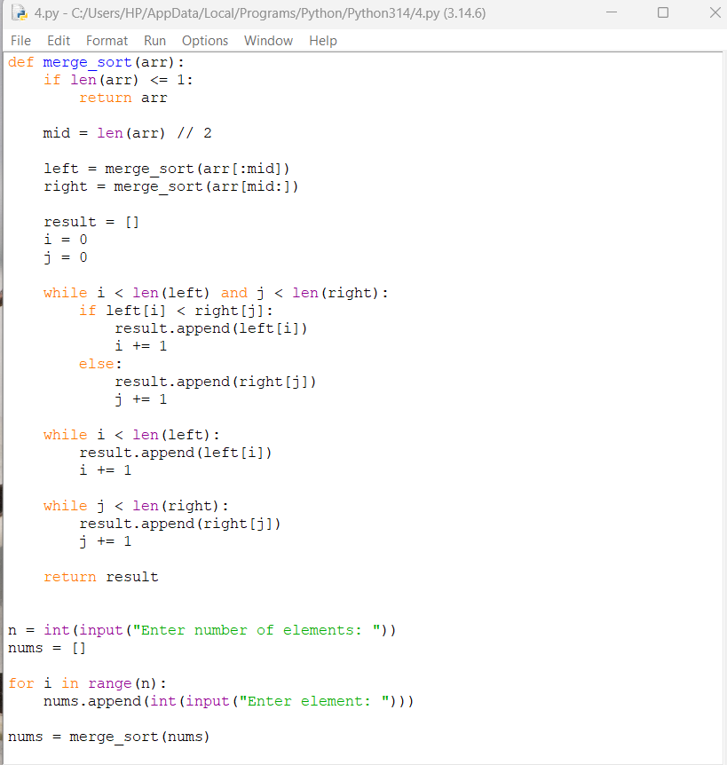
OUTPUT;
